House Hunt — Data Flow & User Stories
How data moves through the system, and the stories that define its behavior

Data Flow Diagrams
House Hunt's data flow centers on three actors — Tenant, Owner, and Admin — all interacting with a single Express API backed by MongoDB. The diagrams below describe what each level should depict; they should be produced as visual DFDs alongside this document.

Level 0 — Context Diagram

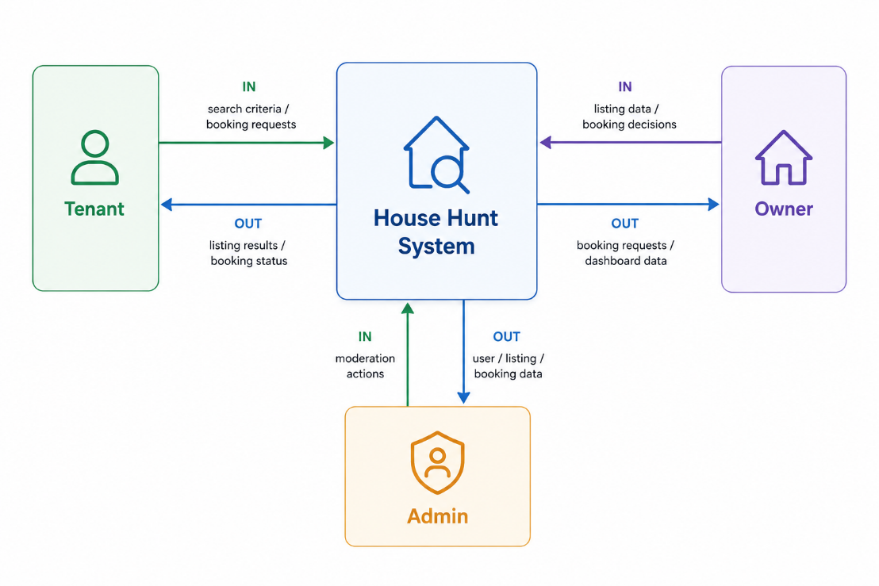

Level 1 — Detailed Process Flow

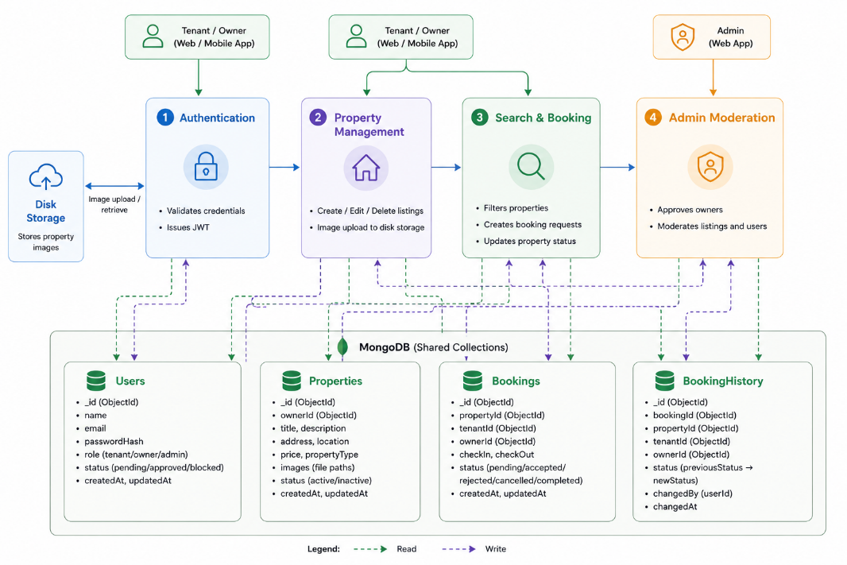

User Stories
The following user stories define House Hunt's functionality from each role's perspective, along with acceptance criteria, priority, and the sprint in which each was targeted for release.
User Type | Epic | Story # | User Story | Acceptance Criteria | Priority | Release
Tenant | Registration | USN-1 | As a tenant, I can register with my name, email, and password so I can create an account. | Account is created and I am redirected to the login page. | High | Sprint-1
Tenant | Login | USN-2 | As a tenant, I can log in with my email and password to access my dashboard. | A JWT is issued and my dashboard loads with my saved data. | High | Sprint-1
Tenant | Search & Discovery | USN-3 | As a tenant, I can search and filter listings by location, rent range, property type, and furnishing status. | Results update to match the filters I've selected. | High | Sprint-2
Tenant | Saved Searches | USN-4 | As a tenant, I can save a search so I can reuse it later without re-entering filters. | The saved search appears in my list and can be re-run with one click. | Medium | Sprint-2
Tenant | Booking | USN-5 | As a tenant, I can submit a booking request with proposed dates so the owner can review it. | A booking record is created with status Pending and is visible in my history. | High | Sprint-3
Tenant | History | USN-6 | As a tenant, I can view my past property views and booking requests. | My last 10 viewed properties and all my bookings are listed with their status. | Medium | Sprint-3
Tenant | Profile | USN-7 | As a tenant, I can update my name, phone, location, and profile photo. | Changes are saved and reflected immediately on my profile page. | Low | Sprint-4
Owner | Registration | USN-8 | As an owner, I can register so I can eventually list properties. | My account is created with approval status pending until an admin reviews it. | High | Sprint-1
Owner | Listing Management | USN-9 | As an owner, I can create a property listing with photos so tenants can view it. | The listing is saved with up to 5 images and appears in tenant search results once approved. | High | Sprint-2
Owner | Listing Management | USN-10 | As an owner, I can edit or delete my own listings. | Only listings I own can be edited or deleted; changes are reflected immediately. | Medium | Sprint-2
Owner | Booking Management | USN-11 | As an owner, I can confirm or cancel booking requests submitted for my properties. | Confirming a request updates the property status to Booked; cancelling keeps it Available. | High | Sprint-3
Admin | Owner Approval | USN-12 | As an admin, I can approve or reject owner accounts so only verified owners can publish listings. | Approved owners can immediately create listings; rejected/unapproved owners cannot. | High | Sprint-1
Admin | Listing Moderation | USN-13 | As an admin, I can view and remove any property listing on the platform. | Any listing can be deleted by an admin regardless of which owner created it. | Medium | Sprint-3
Admin | Booking Oversight | USN-14 | As an admin, I can view all bookings across the platform for oversight. | A complete list of bookings, with tenant, owner, and property details, is visible to admins. | Low | Sprint-4

